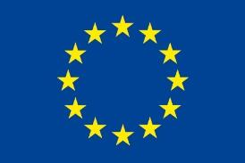
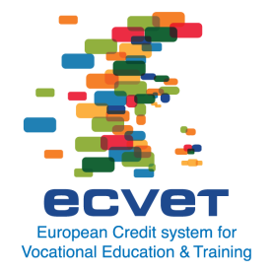
Memorandum of Understanding
- Objectives of the Memorandum of Understanding
The Memorandum of Understanding (MoU) forms the framework for cooperation between the competent institutions. It aims to establish mutual trust between the partners. In this Memorandum of Understanding partner organisations mutually accept their respective criteria and procedures for quality assurance, assessment, validation and recognition of knowledge, skills and competence for the purpose of transferring credit.
Are other objectives agreed on? Please tick as appropriate | ☐ No  ☐ Yes

- Organisations signing the Memorandum of Understanding
Organisation 1
Country
Name of organisation
Address
Telephone/fax
E-mail
Website
Contact person
Telephone/fax
E-mail
Organisation 2
Country
Name of organisation
Address
Telephone/fax
E-mail
Website
Contact person
Telephone/fax
E-mail

- The qualification(s) covered by this Memorandum of Understanding
Qualification 1
Country
Title of qualification
Unit(s) of learning outcomes for the mobility phases (refer to enclosure in the annex, if applicable)
Enclosures in annex - please tick as appropriate

- Assessment, documentation, validation and recognition
By signing this Memorandum of Understanding we confirm that we have discussed the procedures for assessment, documentation, validation and recognition and agree on how it is done.
- Validity of this Memorandum of Understanding
- Evaluation and review process

- Signatures
Organisation / country | Organisation / country
Name, role | Name, role
Place, date | Place, date

- Annexes

For more information and guidance on the establishment of a MoU please refer to the ECVET User’s Guide: ‘Using ECVET for geographical mobility (2012) - Part II of the ECVET Users’ Guide - Revised version – including key points for quality assurance’ – available at: http://www.ecvet-projects.eu/Documents/ECVET_Mobility_Web.pdf

